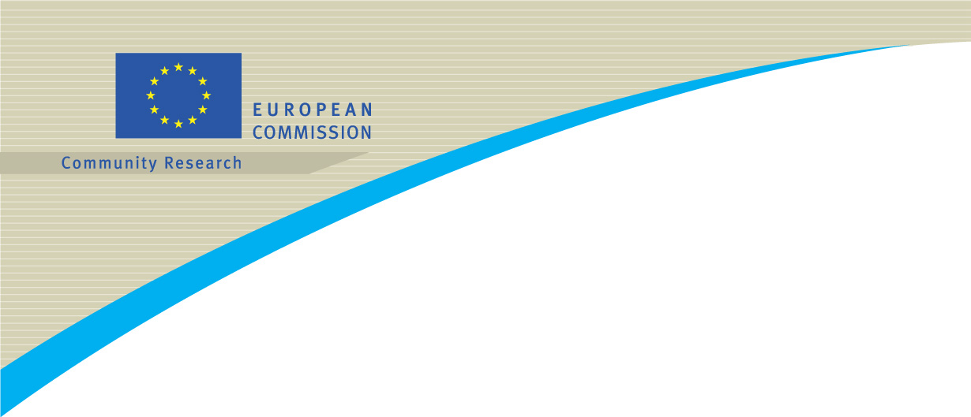

Brussels, 15 March 2005

Researchers in Europe 2005
European Researchers' Night

The European Commission's “Researchers in Europe 2005” Initiative is making this a special year for European research.

The specific objectives of the Initiative, lasting from June to November 2005:

- bring the researchers closer to the public
- attract young people to scientific careers
- increase Europe’s attractiveness as hosting territory for researchers

European Researchers' Night is one opportunity to offer a “platform” where all stakeholders involved from students, teachers and parents, to businesses, research organisations, public authorities and foundations to express and exchange views on the researcher’s profession and the researcher’s contribution to society. Many cities across the 25 Member States are planning to host activities on European Researchers' Night, which will take place on Friday, 23 September 2005.

This document gives additional background about European Researchers' Night and provides tips and ideas for developing Researchers' Night activities.

Strategy:
Give the public and in particular the young people the opportunity to meet researchers in occasion of festive, "out of the ordinary" activities

How it works:
National and regional organisers of scientific events – businesses, academic institutions, research organisations, public authorities, etc. – develop ideas for activities and host event(s) on Friday, 23 September. Customised activities should suit citizens' interests and be designed to attract in particular young people.

The European Commission will
- act as a catalyst for ideas
- serve as a sounding board,
- answer questions that might arise during the development and execution of the events
- organise a mutually-beneficial co-operation.

Should you organise Researchers' Night activities on 23 September 2005:
The European Commission would
- integrate your event into the official Researchers in Europe Programme,
- include it on the Initiative dedicated website (http://europa.eu.int/researchersineurope)
- provide you with promotional and media materials, information and materials for distribution on-site, etc.

We would be delighted to further discuss additional options with you.

Ideas for Researchers' Night Activities and Events:
Opportunities for events could range from science cafés to multi-city co-operations for offering "open-house" research facilities, to exhibitions and special performances, to "Science in the Streets" x-ray laser demonstrations…

In short, you are encouraged to provide an opportunity to give the general public, particularly young people, the chance to approach researchers, meet and talk to them, and most of all, to have fun with them:

- Organise an event that is oriented to young people – such as one that features popular music, current movies, DJs, interactive theatre, etc.
- Consider opening museums or labs that are normally closed to the pubic in an effort to give people the chance for an exclusive "behind-the-scenes" glimpse at the research profession and its fascinating aspects.
- Explain how the researchers’ work eases our daily life(concrete applications of research’s results)
- Include the participation of both well-known ,and "unknown" researchers as well
- Partner with local universities, clubs, businesses and other stakeholders to maximise visibility.

Key Messages to Communicate:
- Scientific research is fun.
- Researchers are "normal" people: they have families, hobbies, passions, an inclination to dream, and a fascinating job.
- Researchers' work touches every facet of everyone's day-to-day lives.
- Researchers' talents range widely, and they apply these talents across diverse tasks in a variety of environments.

FOR MORE INFORMATION:
http://europa.eu.int/researchersineurope

FOR ADDITIONAL INFORMATION or to discuss ideas for your local event, CONTACT:

Colette Renier
European Commission
Directorate General for Research
Tel: +32 2 299 8876 E-mail: colette.renier@cec.eu.int

Monika Adamova
Hill & Knowlton International, Contractor to the European Commission
Tel: +32 2 739 1673 E-mail: madamova@hillandknowlton.com

